**電腦網路期末Project**

B063040061

陳少洋

Step1.

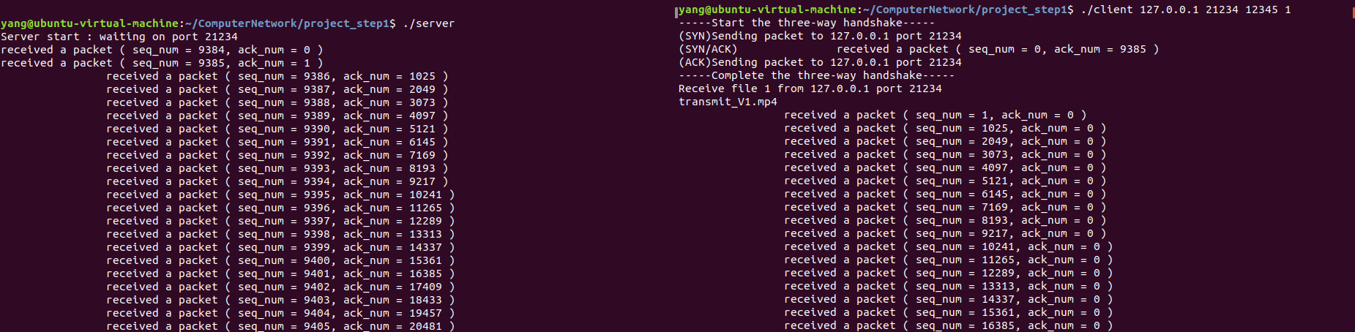server client

中段省略

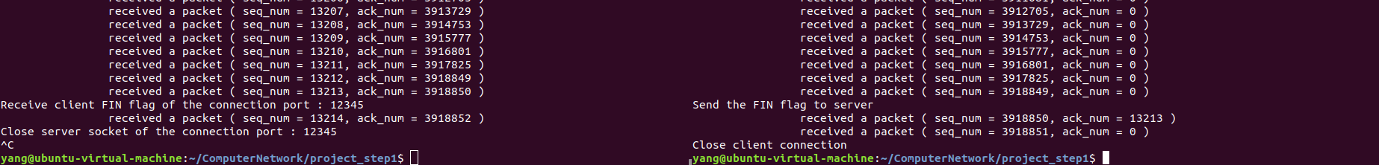

Step2.

server client

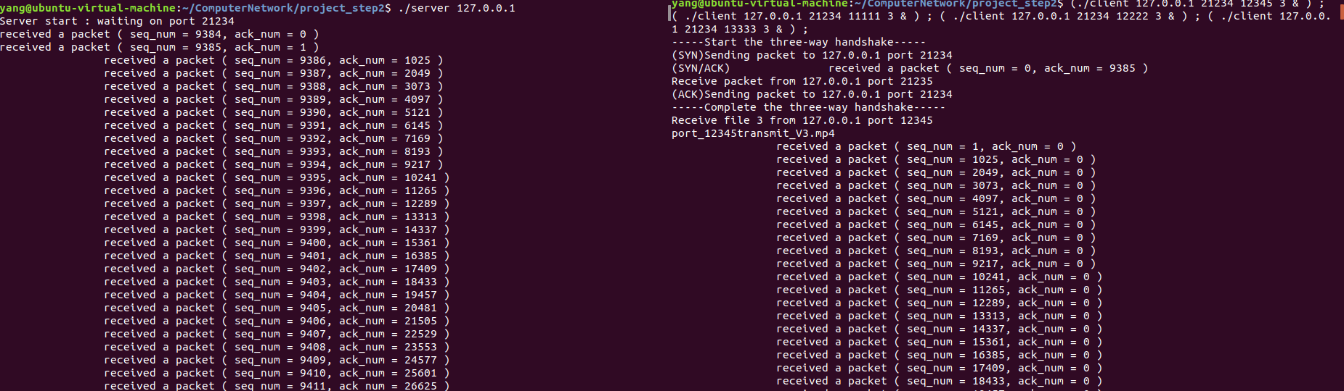

中段省略

中段省略

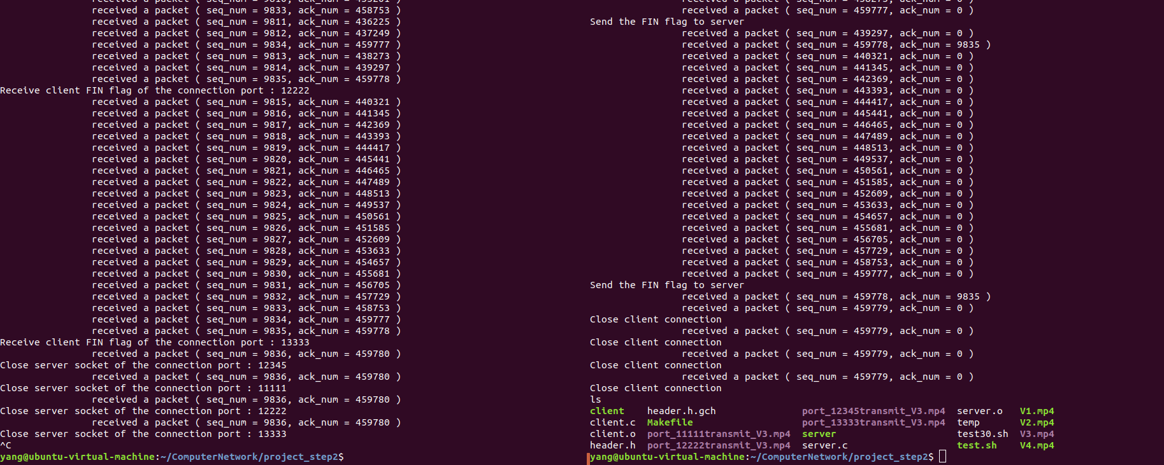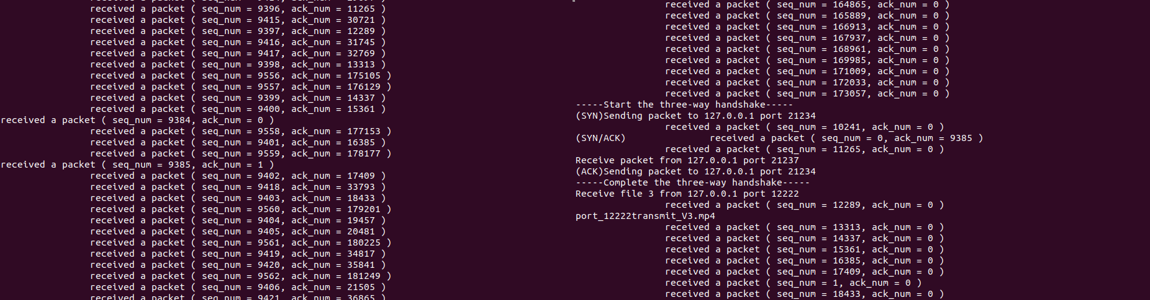

Step3.

server client

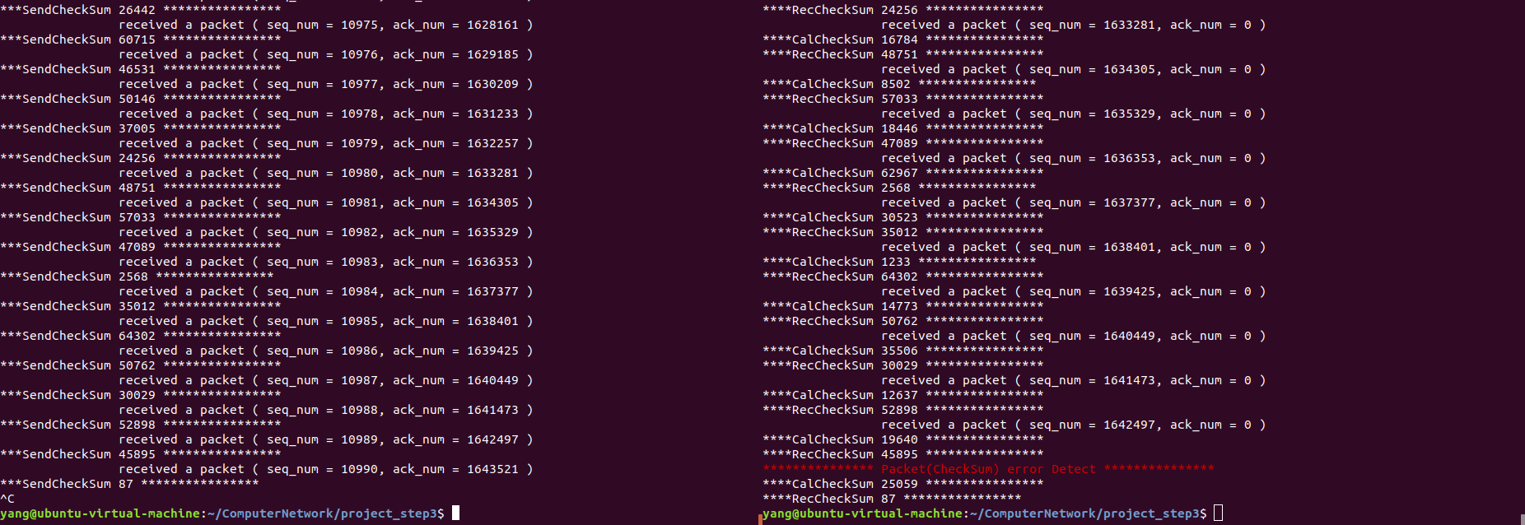

Step4.

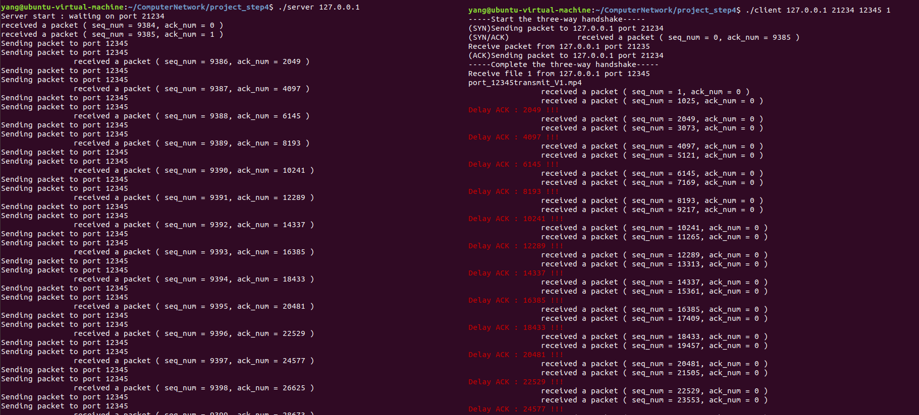

server client

Step5.

server client

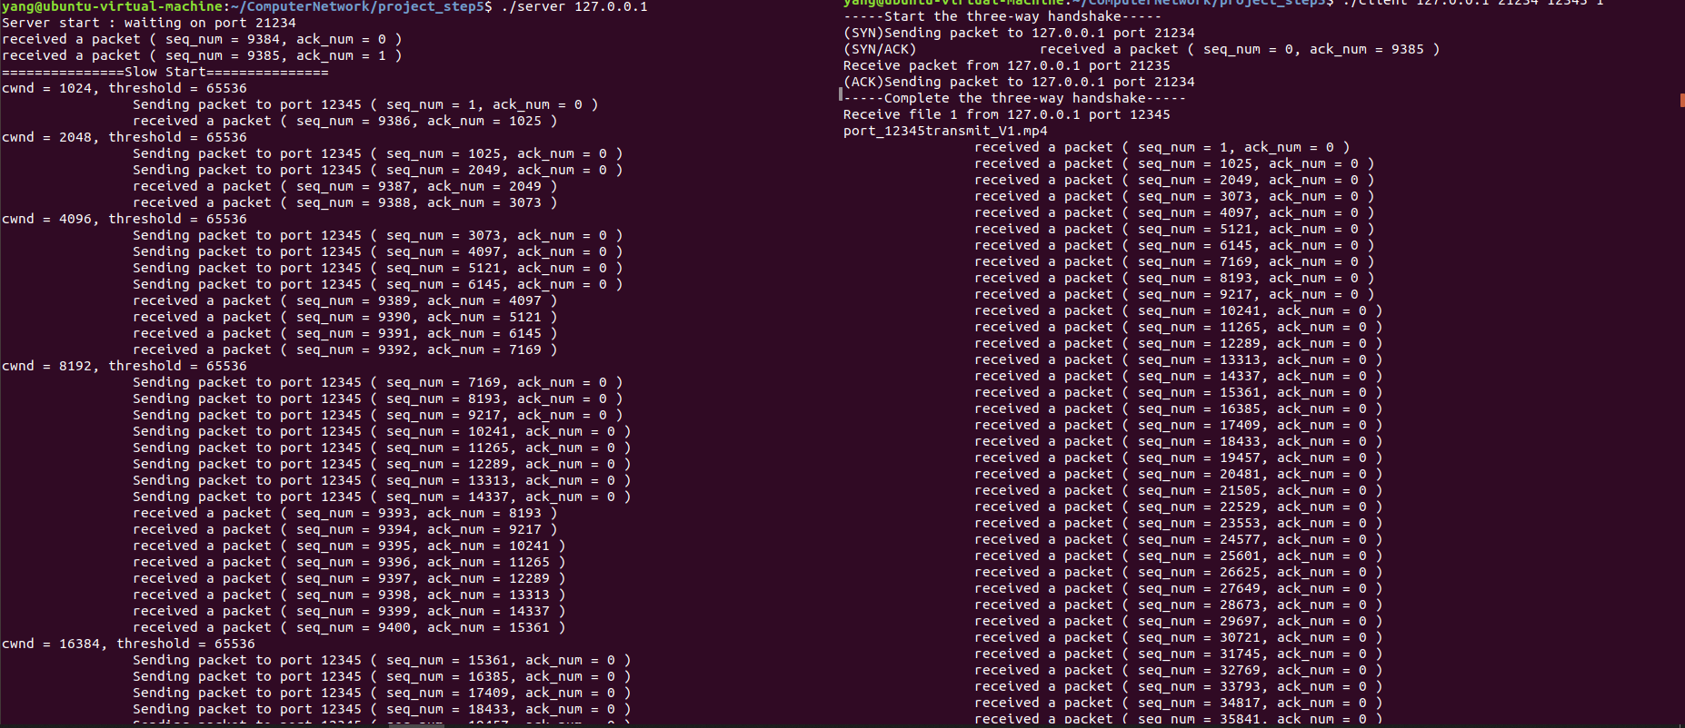

( slow start )

( congestion avoidance )

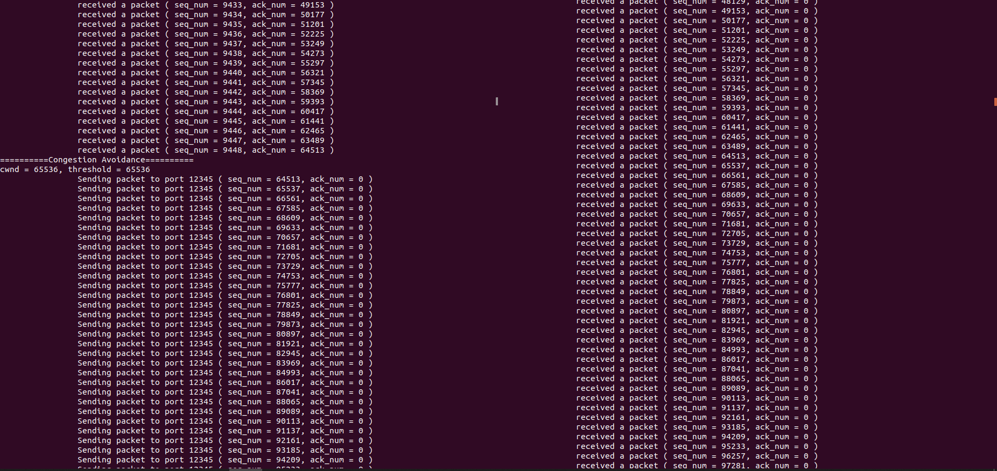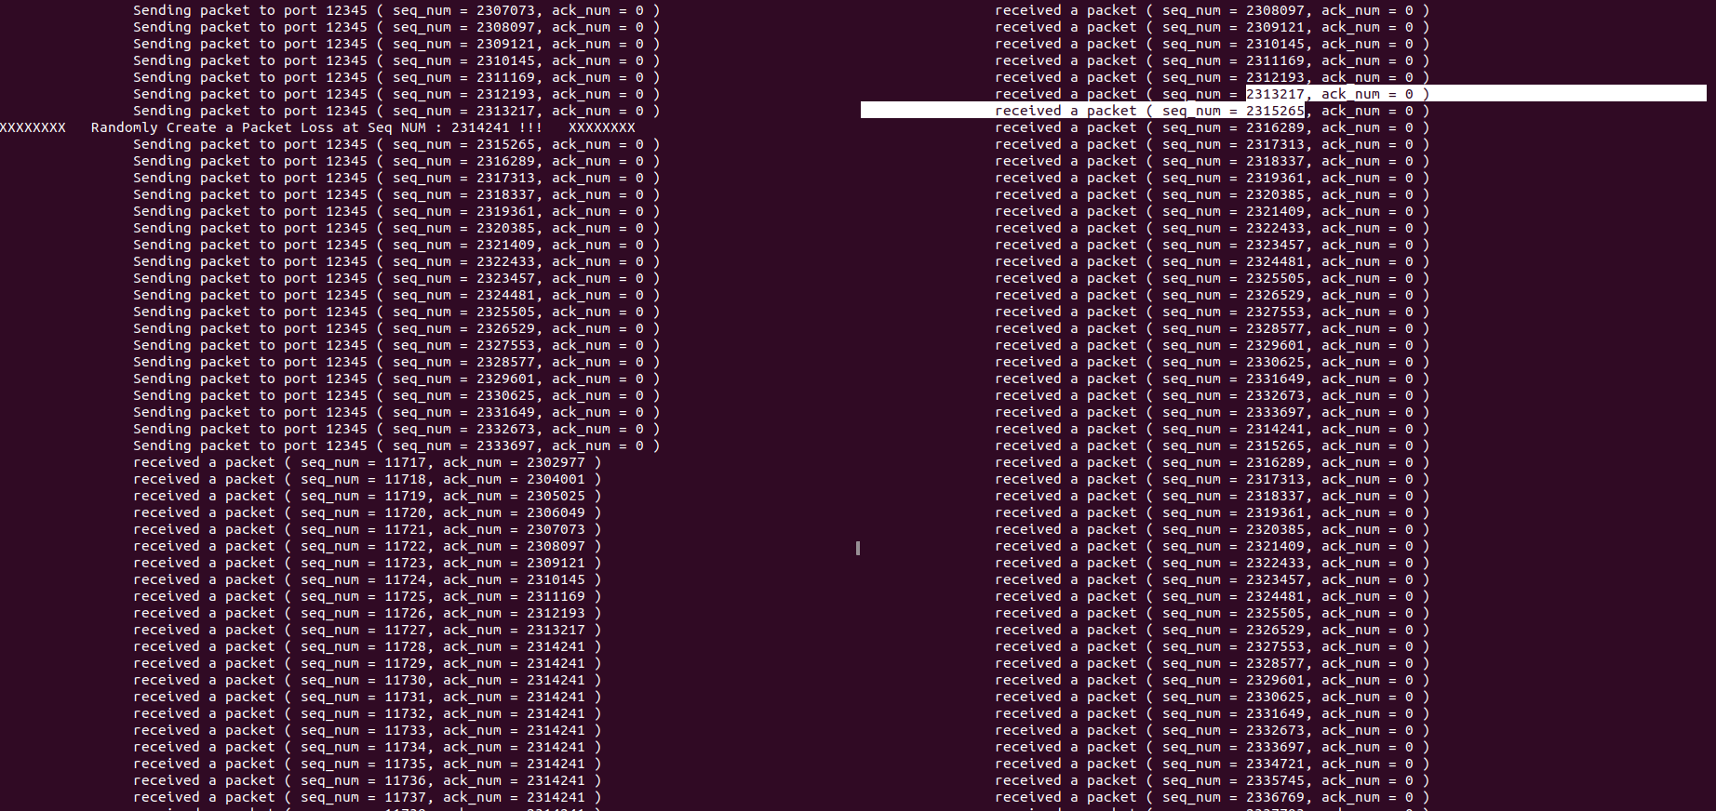

( packet loss )

( packet loss after time out )

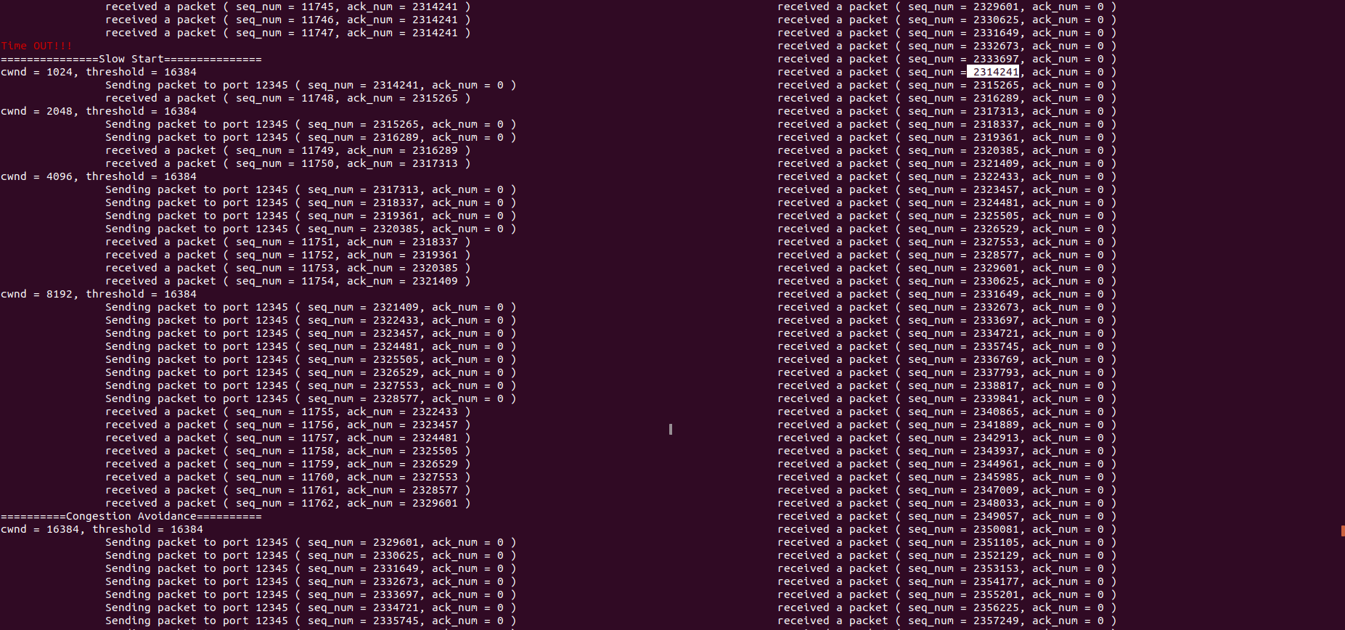

Step6.

server client

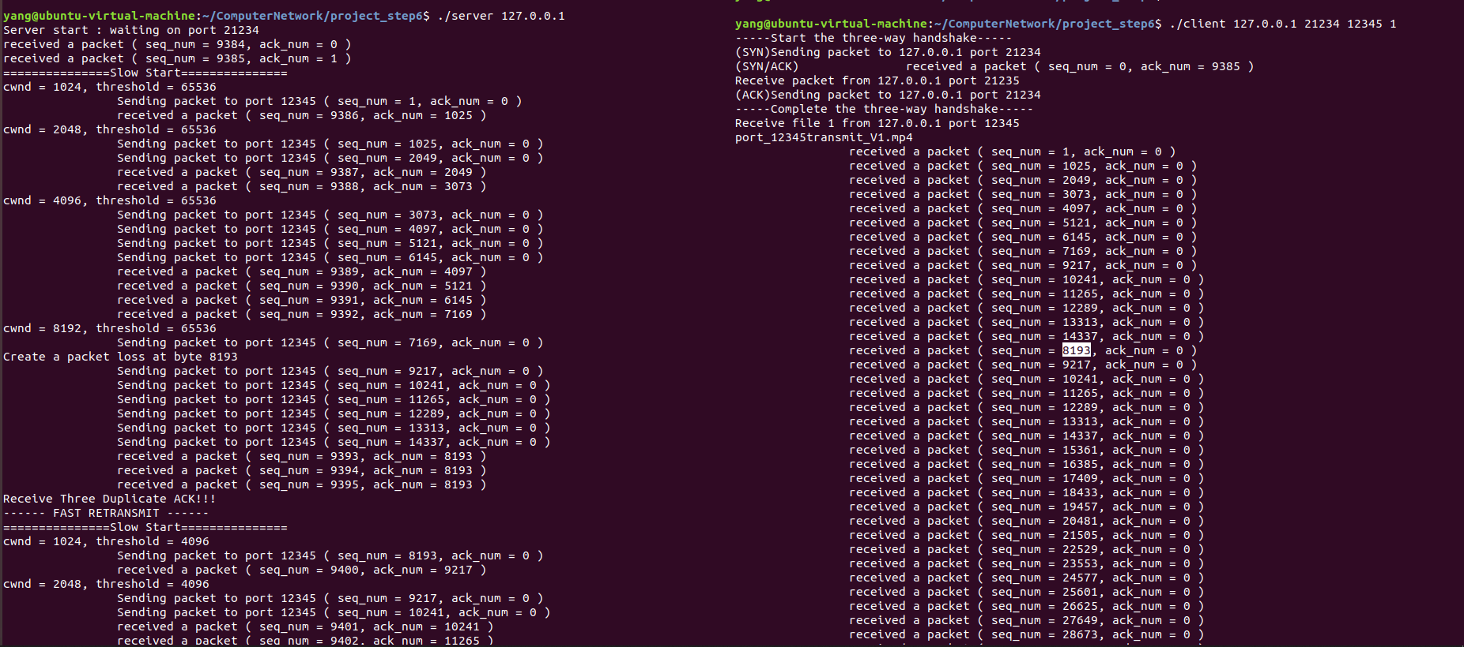

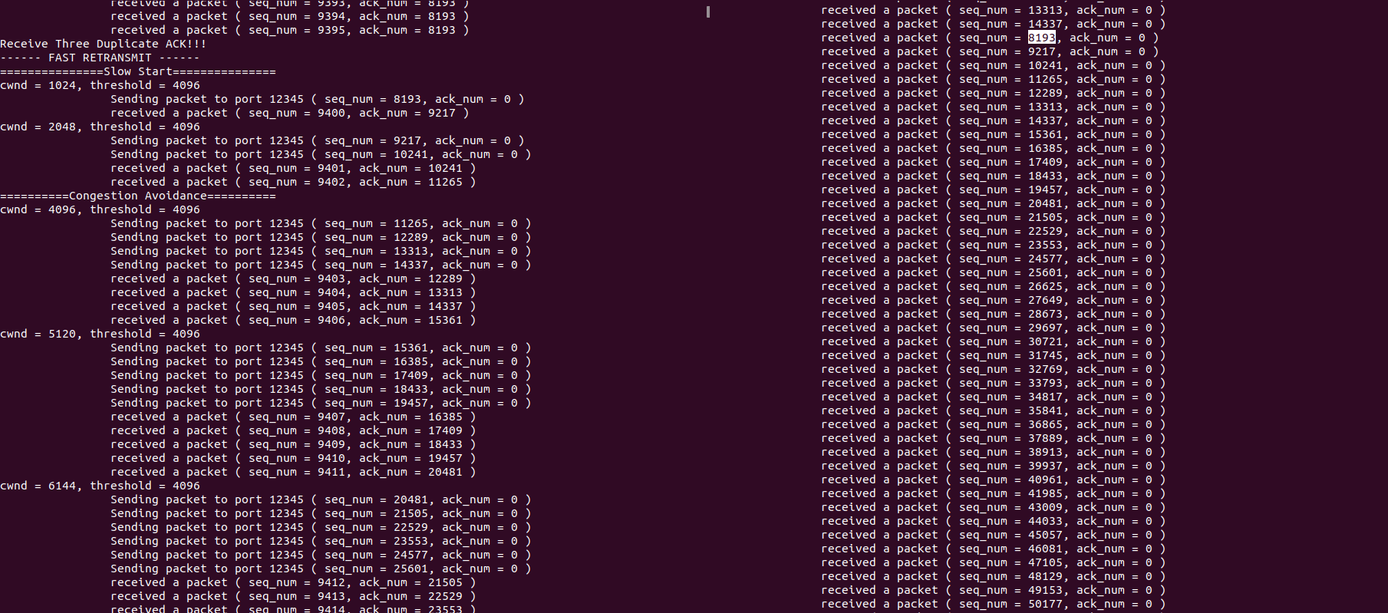( packet loss at 8192 byte )

Step7.

server client

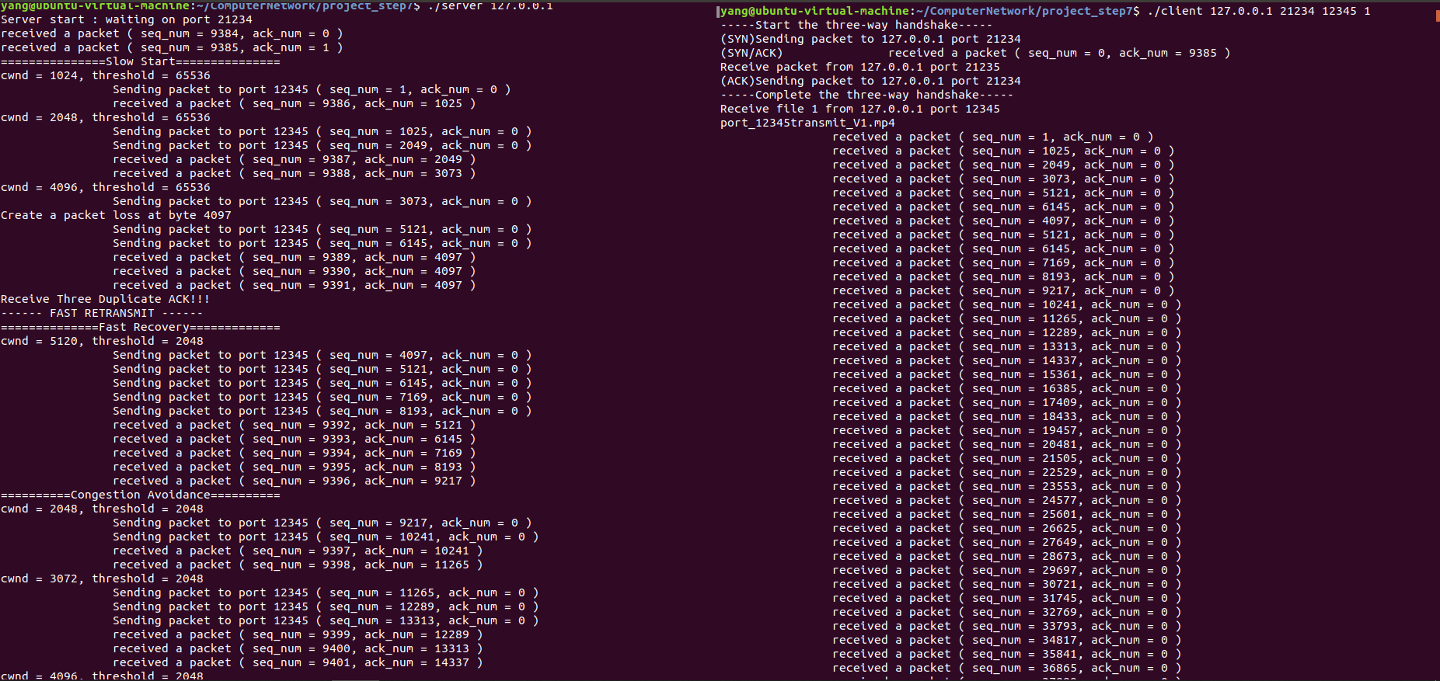

( packet loss at 4096 byte )

Step9.

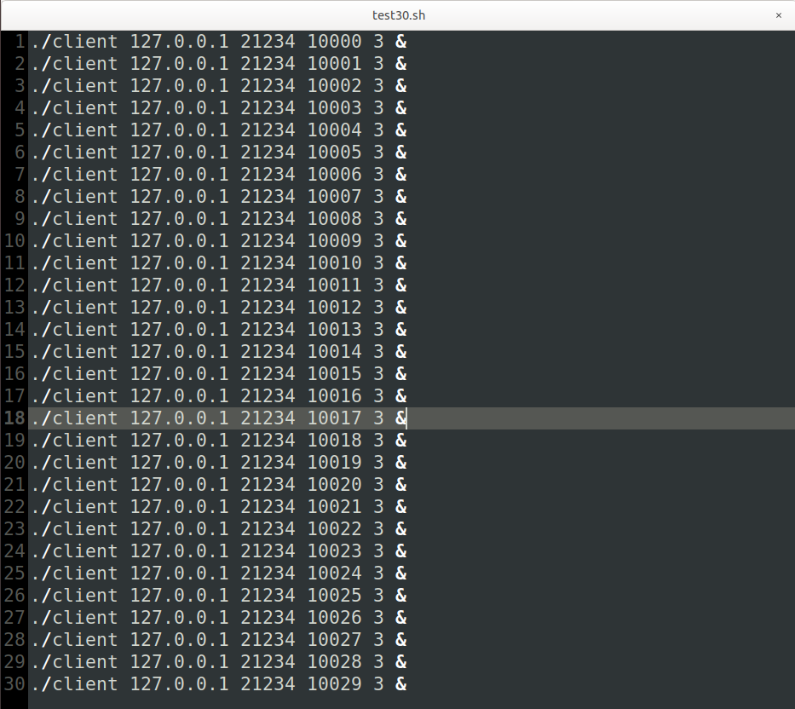

server client ( 30 clients )

